**SQL ASSIGNMENT- 2**

Q1. Write an SQL query to print the first three characters of FIRST_NAME from worker table.

**Solution:**

Step-1. Using the SUBSTRING function to print the first three characters of FIRST_NAME from worker table.

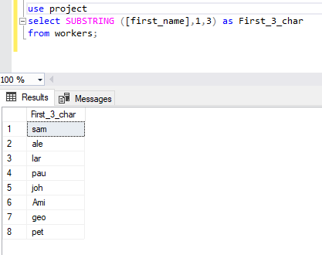

Q2. Write an SQL query to find the position of the alphabet(‘a’) in the FIRST_NAME column ‘Amitabh’ from Worker table.

**Solution:**

Step-2. Select CHARINDEX function to find the position of a particular character in a string

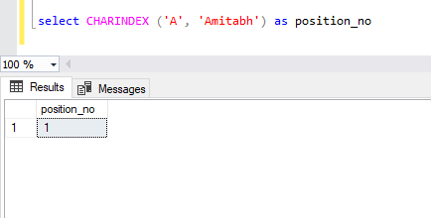

Q3. Write an SQL query to print the name of employees having the highest salary in each department.

**Solution:**

Step-3. Use the MAX function to find the maximum salary and group by the table by the department

